## Upgrading Content from SharePoint 2007 to 2010

**Lab Time**: 45 minutes

**Lab Folder**: C:\Student\Labs\08.Upgrade

**Lab Overview**: There are different upgrade scenarios available to upgrade a SharePoint 2007 web application to SharePoint 2010. In this lab exercise you will perform a database attach upgrade. When you opt for this type of upgrade, you will upgrade only the content of your environment and not the configuration settings. Using a database attach upgrade is useful when you are changing hardware or want to reconfigure your server farm topology as part of the upgrade process. This type of upgrade is only possible on a properly configured SharePoint 2010 installation.

### Exercise 1: Preparing SharePoint 2007 Content Databases for Upgrade

In this first exercise you will just read. We are providing you with a backup file for a SharePoint 2007 content database. This content database was prepared and backed up in a SharePoint 2007 farm and it is now ready to migrate to your SharePoint 2010 farm using the database attach migration strategy. This first exercise will simply walk you through the steps of what was done to prepare the content database backup in the SharePoint 2007 environment.

1. There are a number of steps you must perform in the SharePoint 2007 environment before you can upgrade the content database. These are the high level steps that were used to prepare the backup file used in the next exercise. *Don’t do these steps … this is an overview of what you would have done do a SharePoint 2007 environment.*
   1. Run **STSADM –o preupgradecheck** in SharePoint 2007 farm to determine whether there are any upgrade issues that you need to address.
   2. Set the SharePoint 2007 content database(s) to be upgraded to read-only.
   3. Back up the SharePoint 2007 content databases by using SQL Server tools.
   4. Copy the backup file for the 2007 content database to the database server in your SharePoint 2010 farm.

### Exercise 2: Restoring the Database in a SharePoint 2010 farm

In this step you will use the SQL Server database management tools to restore a SharePoint 2007 con tent database so you can begin the database attach upgrade process.

1. Log on to the **WingtipServer** VM.
2. Using the Windows Explorer, navigate to [[Lab Files]]\Starter Files. Verify that you can locate the database backup file named WingtipSales2007_ContentDB.bak and a batch file named CopyBackup.bat.
3. Double click on the batch file named CopyBackup.bat. This will copy the Wingtip Sales content database backup file to the default location used by SQL Server 2008 R2.

C:\Program Files\Microsoft SQL Server\MSSQL10_50.MSSQLSERVER\MSSQL\Backup

1. Open the SQL Server Management Studio from the Windows Start menu using shortcut at **Start » All Programs » Microsoft SQL Server 2008 R2 » SQL Server Management Studio**.

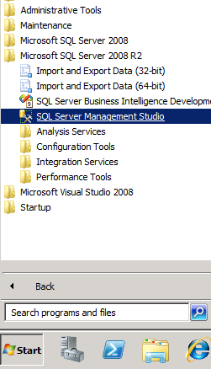

1. Once you have launched SQL Server Management Studio, connect to the **Database Engine** on the server named **(local)**.

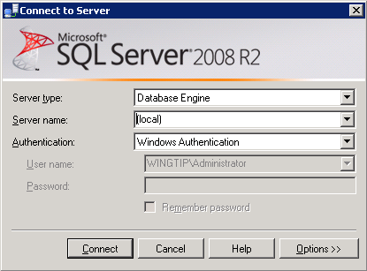

1. Expand the **Databases** node to see the existing databases. Right-click on the **Databases** node and select the **Restore Database** command.

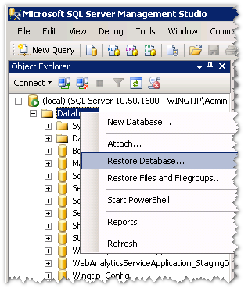

1. In the **Restore Database** dialog, locate the section titled **Source for restore** and select the **From Device** option. Click the button to the right with the ellipse (…) to add a new device using the **Specify Backup** dialog. Click the **Add** on the **Specify Backup** dialog to bring up the **Locate Backup File** dialog. In the **Locate Backup File** dialog, select the backup file named WingtipSales2007_ContentDB.bak. Click **OK** to close the **Locate Backup File** dialog and then click **OK** to close the **Specify Backup** dialog. At this point, you should be back at the **Restore Database** dialog.

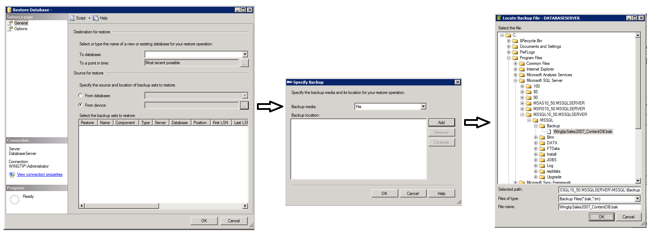

1. On the **Restore Database** dialog, locate dropdown control with the caption **To database** in the **Destination for restore** section. You should be able to drop down the **To database** control and select the target database to restore named **WingtipSales2007_ContentDB**. Also ensure you check the checkbox for the backup in the **Restore** column in the **Select the backup sets to restore** section as shown in the screenshot below. Now that you have the provided entries for the **From device** option and **To Database** option, click the **OK** button in the **Restore Database** dialog to begin the database restore operation.

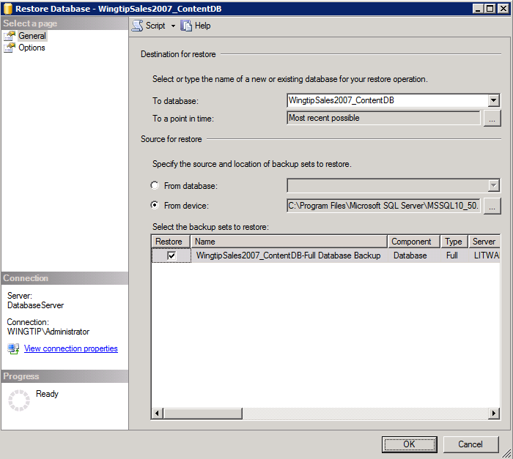

1. Once the **WingtipSales2007_ContentDB** database has been restored, you can close the SQL Server Management Studio.

### Exercise 3: Mounting the Restored Content Database

In this step you will create a new Web application at [**http://sales.wingtip.com**](http://sales.wingtip.com) and you will mount the restored database to upgrade SharePoint 2007 content to SharePoint 2010.

1. You will start by creating a DNS A record to resolve requests to sales.wingtip.com to the IP address of the **WingtipServer** VM which is 192.168.150.1.
2. Start DNS Manager from **Start » Administrative Tools » DNS**.

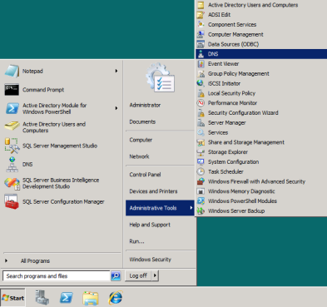

* 1. In the DNS Manager, navigate down the hierarchy of node to **DNS » DATABASESERVER » Forward Lookup Zones » wingtip.com**.

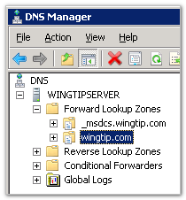

* 1. Right-click on the **wingtip.com** node and create a new A Record by click menu command with the caption of **New Host (A or AAAA)**.

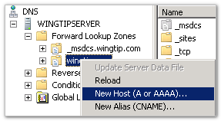

* 1. In the **New Host** dialog enter a **Name** of **sales** and an **IP address** of 192.168.150.1. When you are done click the **Add Host** button to create the new A Record

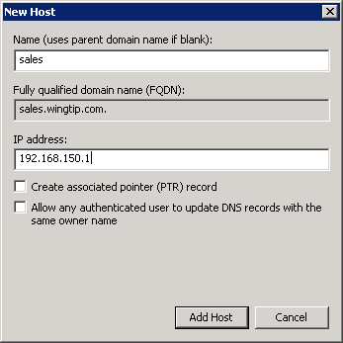

1. Now it is time to test your work. You will ensure that you can resolve the DNS names of sales.wingtip.com to the correct IP address.
2. Bring up a standard Windows command prompt.
3. Ensure you can ping the DNS name of sales.wingtip.com and have it resolve to the IP address of 192.168.150.1.
4. The next step is to create a new Web application so you have a destination to which you can mount the database named **WingtipSales2007_ContentDB**.
5. Open the **SharePoint 2010 Central Administration**.
   1. Click **Application Management**.
   2. Click the **Manage web applications** hyperlink in the Web Applications section.
   3. Click the **New** button on the ribbon to create a new web application. In the New Web Application dialog, choose to make the new Web application use **Classic Mode Authentication** instead of **Claims Mode Authentication**. Fill in the **IIS Web Site** section using the information shown in the following screenshot.

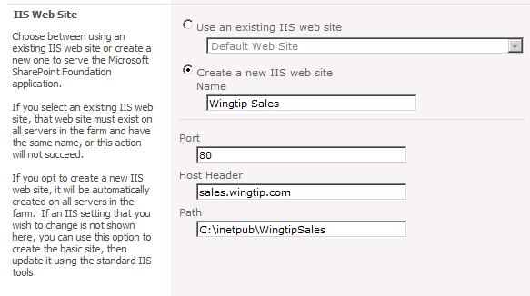

* 1. In the **Public URL** section, enter and URL of http://sales.wingtip.com.

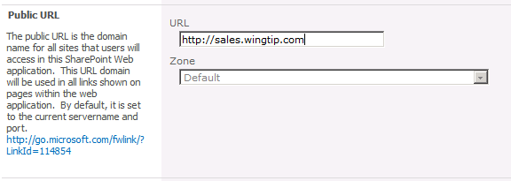

* 1. In the **Application Pool** section, use the application pool created earlier named **Wingtip Web Applications**.

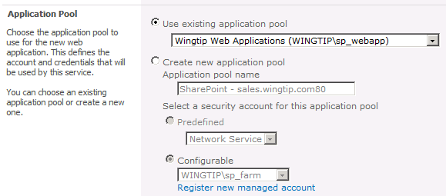

* 1. In the **Database Name and Authentication** section, Enter **WingtipServer** for the Database Server and enter a Database name of **WingtipSales_ContentDB_Temp**.

One thing to watch out for here is prevent database name conflicts. For example do not name the database **WingtipSales_ContentDB** because that is the name of the database that you restored earlier in this lab exercise.

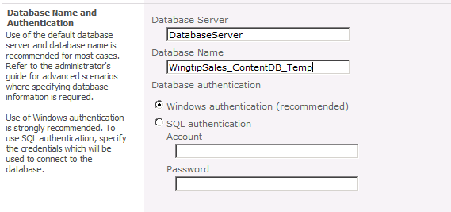

* 1. Click the **OK** button to start the creation of the web application. After the Web application has been created, you are prompted with the following dialog. Do **NOT** create a new site collection at root of the Web application. This would cause problems because the SharePoint 2007 content database already has a site collection at the root URL.

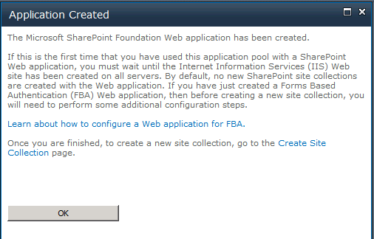

* 1. When you are done with this step, you should be able to confirm that you have created a new Web application at http://sales.wingtip.com.

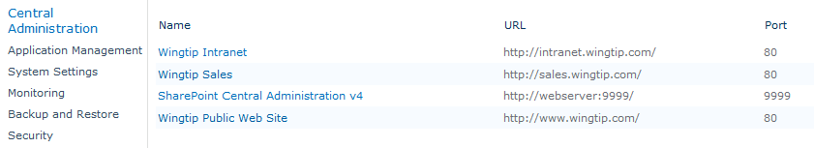

1. Before you attach the content database to upgrade, you can test it to verify if it can be upgraded without problem. There is a PowerShell cmdlet that can do this for you:
2. Start by bringing up the SharePoint PowerShell console window. Navigate to **Start » All Programs » Microsoft SharePoint 2010 Products » SharePoint 2010 Management Shell**.
   1. Type in the following cmdlet and press [Enter] to execute it.

Test-SPContentDatabase -Name "WingtipSales2007_ContentDB " -WebApplication "<http://sales.wingtip.com>"

* 1. This should execute successfully but it may report an error message. This is not an important error so we can continue.

If you have more than one content database to attach, make sure that you first attach the content database containing the root site collection of the web application. After you attach the database that contains the root site, you can attach the other content databases for the Web application in any order. You do not have to create any site collections to store the content before you attach the database; this process creates the site collections for you. Make sure that you do not add any new site collections until you have restored all the content databases.

1. Now it is time to attach the content database to the SharePoint 2010 web application.
2. Use the SPMountDatabase cmdlet to attach the content database. The value of –updateuserexperience is set to false to be able to perform the visual upgrade afterwards.

Mount-SPContentDatabase –Name "WingtipSales2007_ContentDB" –WebApplication "<http://sales.wingtip.com>" –UpdateUserExperience:$false

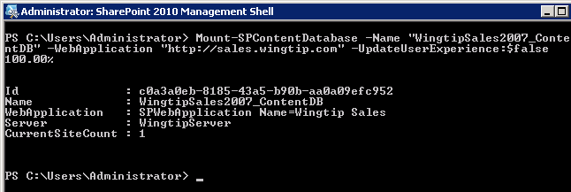

1. When the first content database is upgraded, you can verify that the upgrade was successful from **SharePoint 2010 Central Administration**.
2. In SharePoint Central Administration select **Upgrade and Migration**. There are two links that you can use to view information about the upgrade which are **Review database status** and **Check upgrade status**.

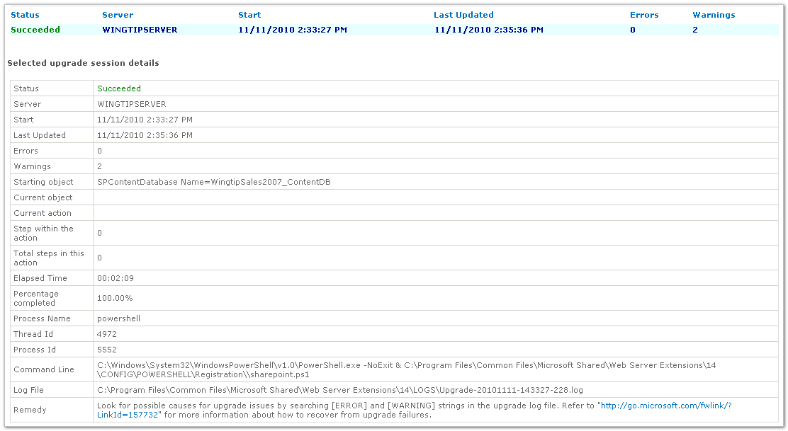

1. Open Internet Explorer and navigate to the site located at <http://sales.wingtip.com>. You should see your site displayed with the old SharePoint 2007 user interface. Also verify that the **Site Actions** menu is currently absent from the page. That is because WINGTIP\Administrator is not a site collection owner. You will fix this in the next step.

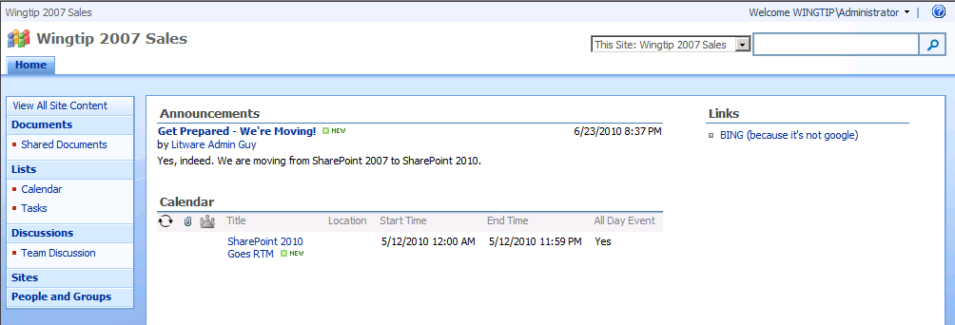

1. There is a problem in that the site collection owner for the site at http://sales.wingtip.com is set to an old account from another Active Directory domain which is not recognized in the wingtip.com domain.
2. Open the **SharePoint 2010 Central Administration**.
   1. Click **Application Management**.
   2. Click the **Change site collection administrators** hyperlink in the **Site Collections** section.
   3. Update the **Primary site collection administrator** for the site collection at http://sales.wingtip.com to the **WINGTIP\Administrator** account.

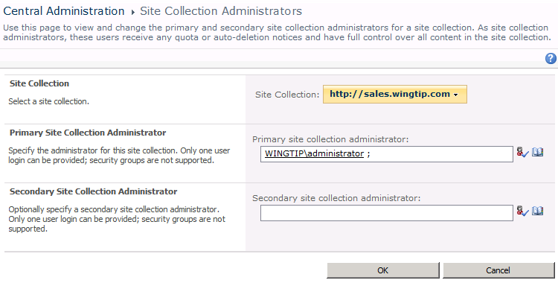

* 1. Navigate back to the site at http://sales.wingtip.com and verify that you can now see the **Site Actions** menu. This will be the case once you are configured as a site collection administrator.

1. Open Internet Explorer and navigate to the site located at http://intranet.wingtip.com. You should see that administrator account does not have access to this site collection. It’s time to correct that.
2. Open the SharePoint Central Administration.
   1. Click **Application Management**.
   2. Click the **Change site collection administrators** hyperlink in the **Site Collections** section.
   3. Update the **Primary site collection administrator** for the site collection at http://intranet.wingtip.com to the WINGTIP\Administrator account.
3. Update the **Secondary site collection administrator** for the site collection to WINGTIP\TedP.
4. Navigate back to the site http://intranet.wingtip.comand verify the Administrator account now has access.

### Exercise 4: Working with Visual Upgrade

When upgrading from SharePoint 2007 to SharePoint 2010, you can opt for the Visual Upgrade method. Visual Upgrade allows administrators to decouple UI upgrade from system upgrade. Visual Upgrade allows you to have SharePoint display the previous UI, allowing you to gradually upgrade the UI on a website-by-website basis. In this exercise you will learn how to execute a Visual Upgrade.

1. If you are not already at the **Wingtip 2007 Sales** site at [**h**ttp://sales.wingtip.com](http://sales.wingtip.com)**,** open the Internet Explorer and navigate there. You should be able to verify it is using the SharePoint 2007 User Interface.



1. From the **Site Actions** menu choose **Visual Upgrade**.
2. When you click **Visual Upgrade**, you’ll see three modes to choose from:
   1. Use the previous UI
   2. Preview the updated UI
   3. Update the UI

The default is to display the previous UI. The preview mode is a useful way to test drive the new UI to see how well it works, allowing you to switch back if needed. Once you switch to the third setting (use the new UI), you can go back only by writing code to reset the setting.

1. Choose the **Preview the updated user interface** mode & click **OK**. This allows you to check if everything looks OK with the new user interface. Users will still see the old UI.
2. If the site looks fine, you can choose the **Update new user interface** option.
3. Navigate back to the home page of the site and look at the new SharePoint 2010 user interface.

